From: Francisca Fuentes francisca@iseverybodyalright.com
FOR IMMEDIATE RELEASE: APRIL 14, 2009
Subject: OSCAR-WINNING DIRECTOR TO TURN HIS CAMERA ON RFK FUNERAL TRAIN
Oscar winner, Jon Blair, director of the acclaimed documentary Anne Frank Remembered, will be turning his camera on Robert Kennedy’s funeral train in the upcoming feature documentary Is Everybody Alright? Blair, his producer Jennifer Stoddart of Lichen Films, and their team are in pre-production on the East Coast of the United States.
Is Everybody Alright? is based on photographs taken by Magnum photographer, Paul Fusco on 8th June 1968 when he captured the stricken mourners who lined the track as Bobby Kennedy’s funeral train passed by. The film will explore the interplay of personal memory and grand historical events of our time. When hundreds of thousands of ordinary people gathered by the trackside to watch Bobby Kennedy’s funeral train pass by, they were perhaps trying to reconcile their own feelings about where they and their country stood at this time of crisis and loss, at the same time as paying homage to the man himself while coming together to mourn the loss of what might have been had he not been assassinated at the age of 42.
Taking its title from Bobby Kennedy’s final words as he lay stricken on the floor in a pool of blood in a California hotel kitchen, Is Everybody Alright? will ask what has become of some of those people who were caught in Paul Fusco’s lens 40 years ago as they came to watch the train go by. This film will be about those people and their lives today. We want to hear their stories and we need help finding them. Please contact us.
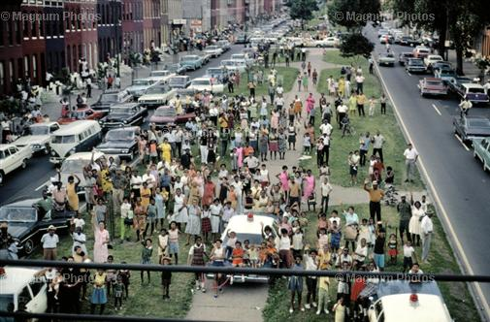
If you'd like more information about this production, please contact Francisca Fuentes (Specialist Researcher) at 202-341-7110 or email francisca@iseverybodyalright.com

Is Everybody Alright? is being made by Scottish based company Lichen Films and is funded by HBO, More4 and Scottish Screen.

